FastAPI Tutorial :

1. Create main.py

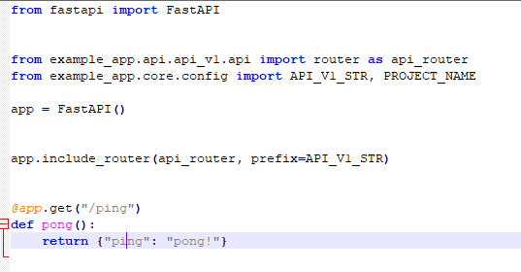

1. Run command: uvicorn main:app –reload

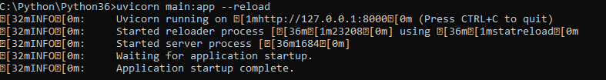

1. Go to the link

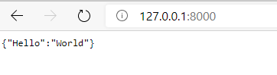

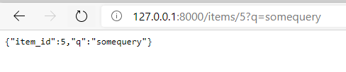

1. 127.0.0.1:8000/docs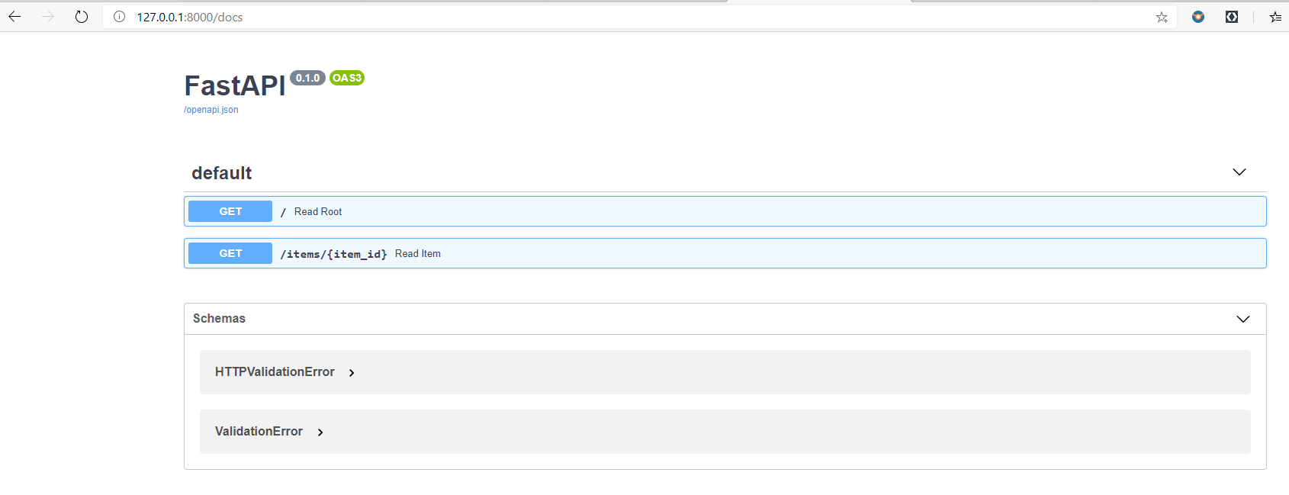
2. 127.0.0.1:8000/redoc

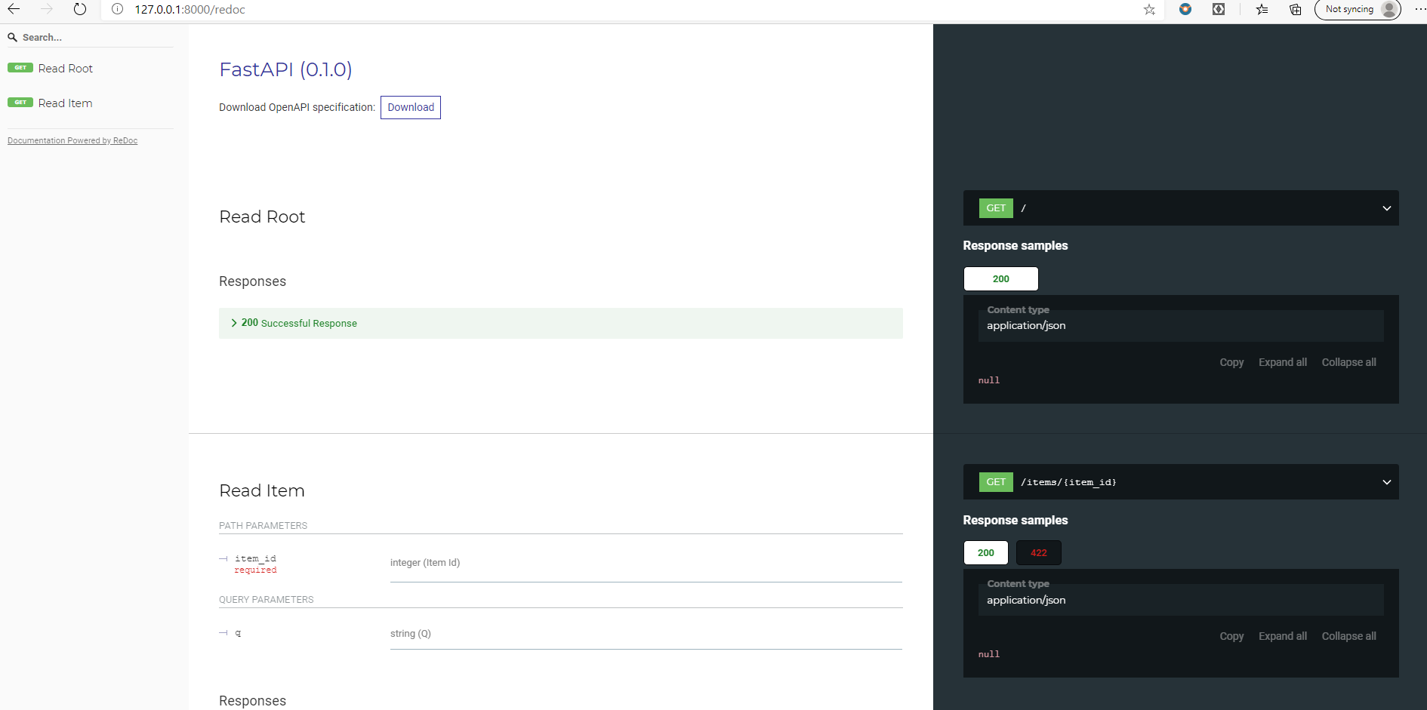

1. Update main.py

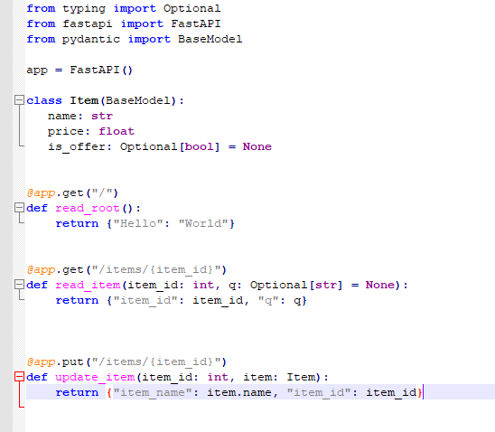

1. 127.0.0.1:8000/docs

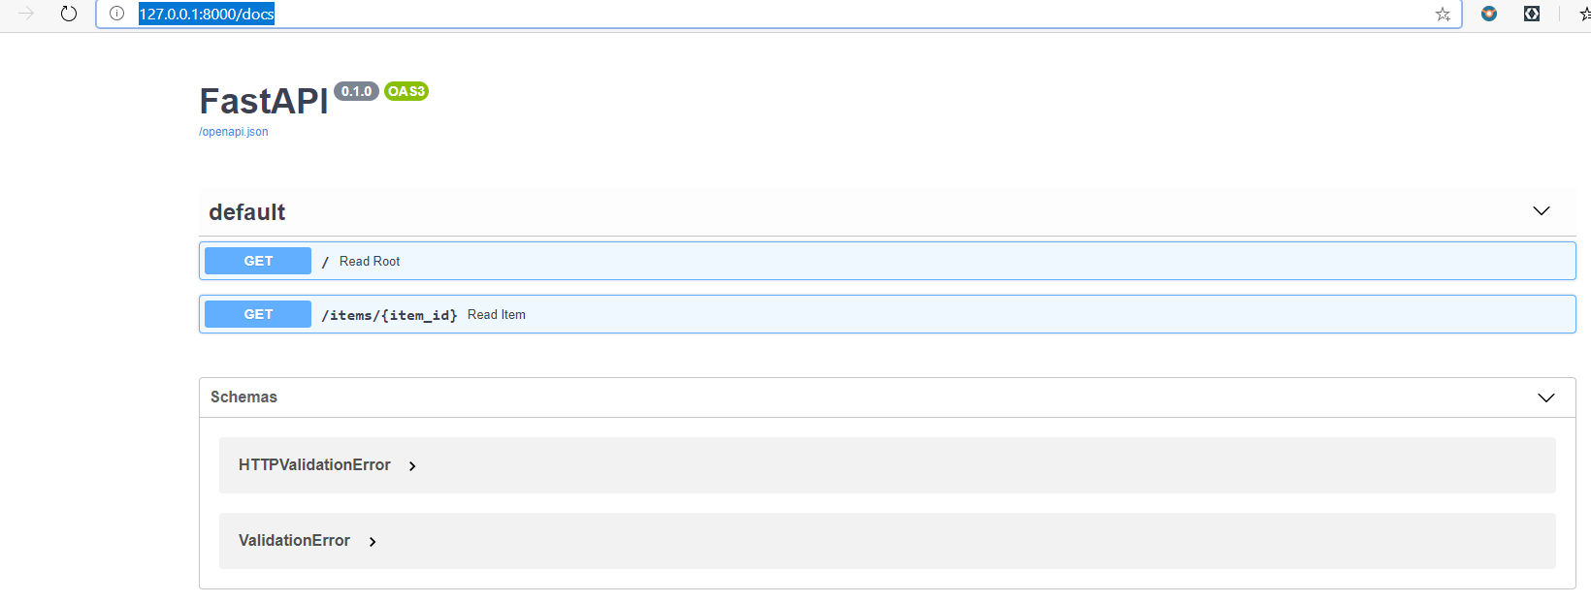

1. 127.0.0.1:8000/redoc

